Scenario 9: VPC Endpoints (Gateway Endpoint + Interface Endpoint)

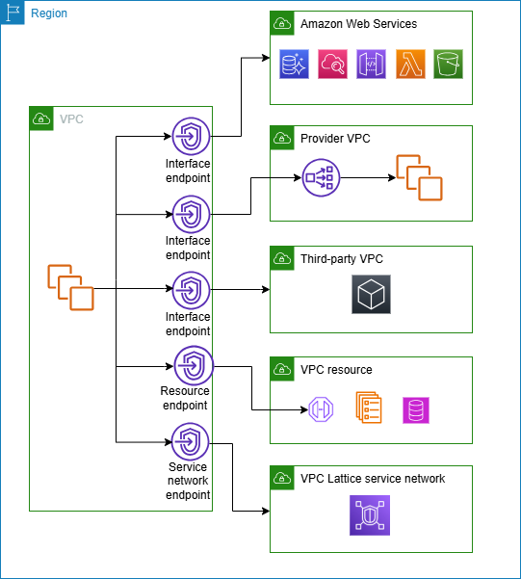
Endpoint Type | Used For | Supported Services | Data Path
Interface Endpoint | Connect to AWS services over private IP | Most AWS services like SSM, CloudWatch, EC2 API, Secrets Manager, etc. | ENI in your subnet
Gateway Endpoint | Connect to S3 or DynamoDB only | S3 and DynamoDB only | Route Table

Services by Endpoint Type
Interface Endpoint Services (most common):
* Amazon SSM
* AWS CloudWatch
* AWS Secrets Manager
* EC2 API
* STS
* KMS
* SageMaker
* ECR (API)
* CloudFormation
* Lambda (Invoke API)
Full list: https://docs.aws.amazon.com/vpc/latest/privatelink/aws-services.html
Gateway Endpoint Services:
* Amazon S3
* Amazon DynamoDB
These are the only two services that support gateway endpoints.

In these scenarios, I have removed the internet gateway from default route table of default subnet of default VPC.
Lets try to connect to s3 and SSM without internet access to servers.
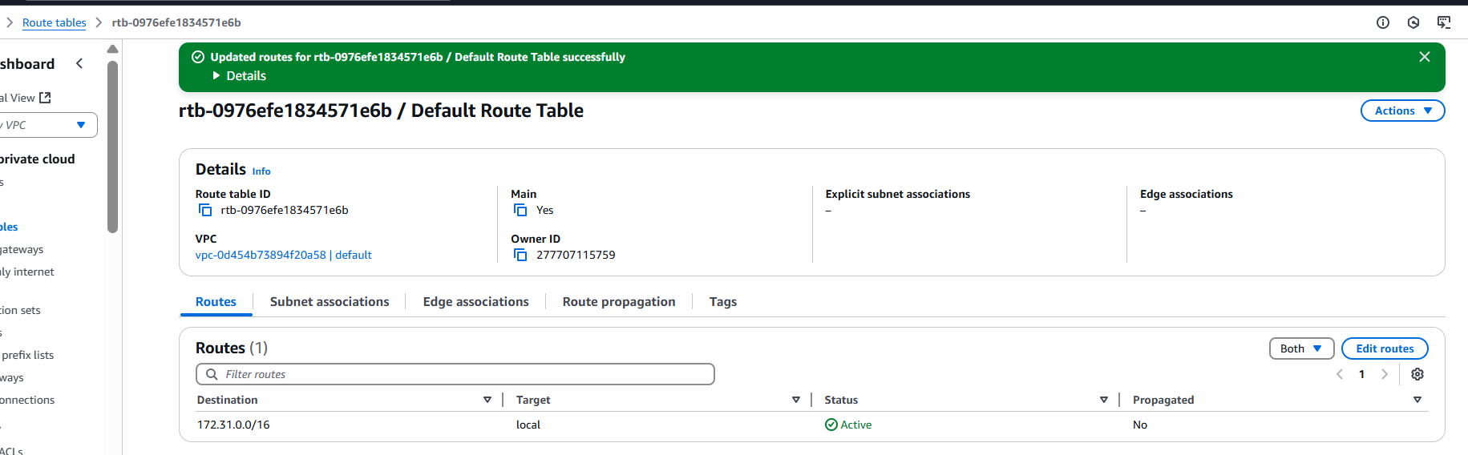
1. Gateway Endpoint (for S3)
Use Case:
Download/upload files to S3 without public internet or NAT gateway.
Steps:
Step 1: Go to VPC Console > Endpoints > Create endpoint.
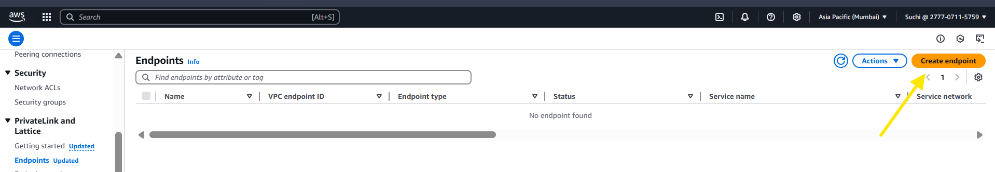

Step 2: Select:
Service category: AWS services
Service Name: com.amazonaws.<region>.s3
Type: Gateway
VPC: Choose your VPC
Route Tables: Select your subnet's route table
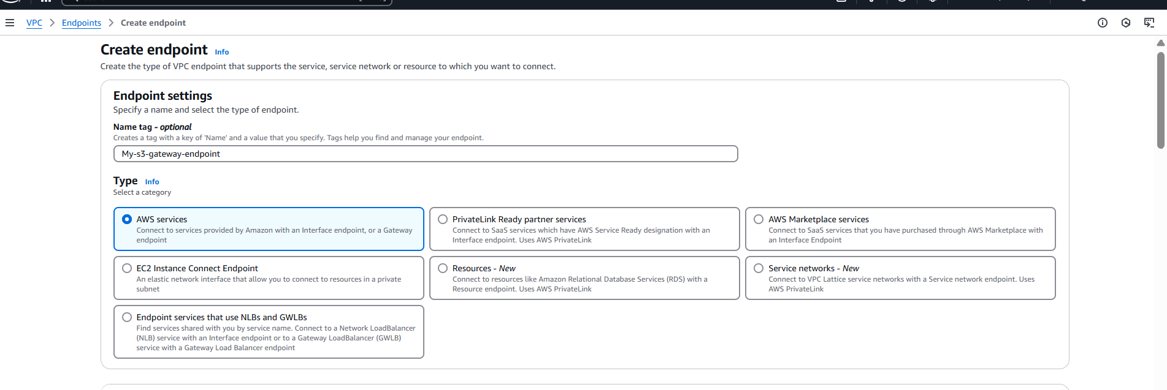
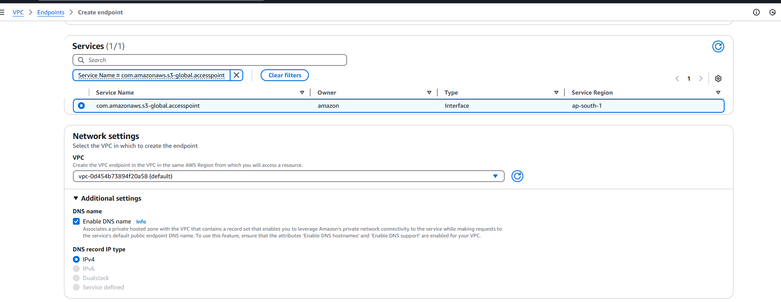
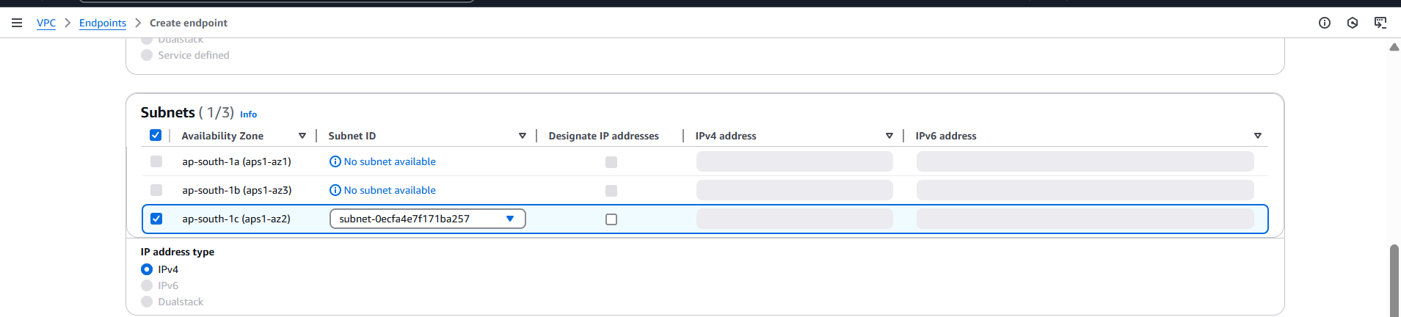
Step 3: Create the endpoint
Test:
From a private EC2 instance (no public IP, no NAT), try:
- Before that need to install the aws cli in that server.
aws s3 ls s3://your-bucket-name
Expected Result:
S3 listing works (through VPC gateway endpoint)
No internet.
No NAT.
Only private AWS network.

2. Interface Endpoint (for SSM)
Use Case:
Manage EC2 with SSM (Session Manager) from a private subnet without internet.
Steps:
Step 1: Go to VPC Console > Endpoints > Create endpoint.
Step 2: Select:
Service Name: com.amazonaws.<region>.ssm
Required VPC Endpoints:
- com.amazonaws.ap-south-1.ssm
- com.amazonaws.ap-south-1.ec2messages
- com.amazonaws.ap-south-1.ssmmessages
Type: Interface
VPC: Choose your VPC
Subnets: Choose the subnet
Enable private DNS: Yes
Security Group: Allow HTTPS (port 443)
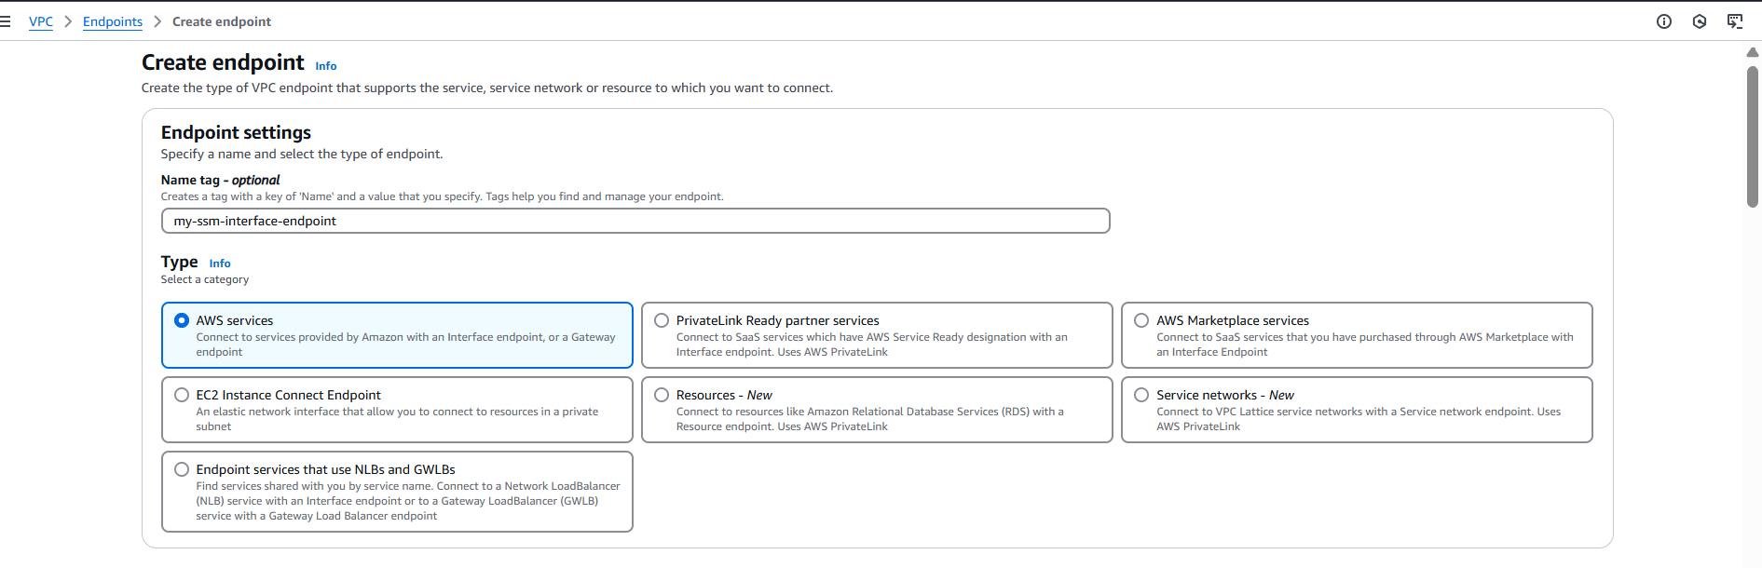
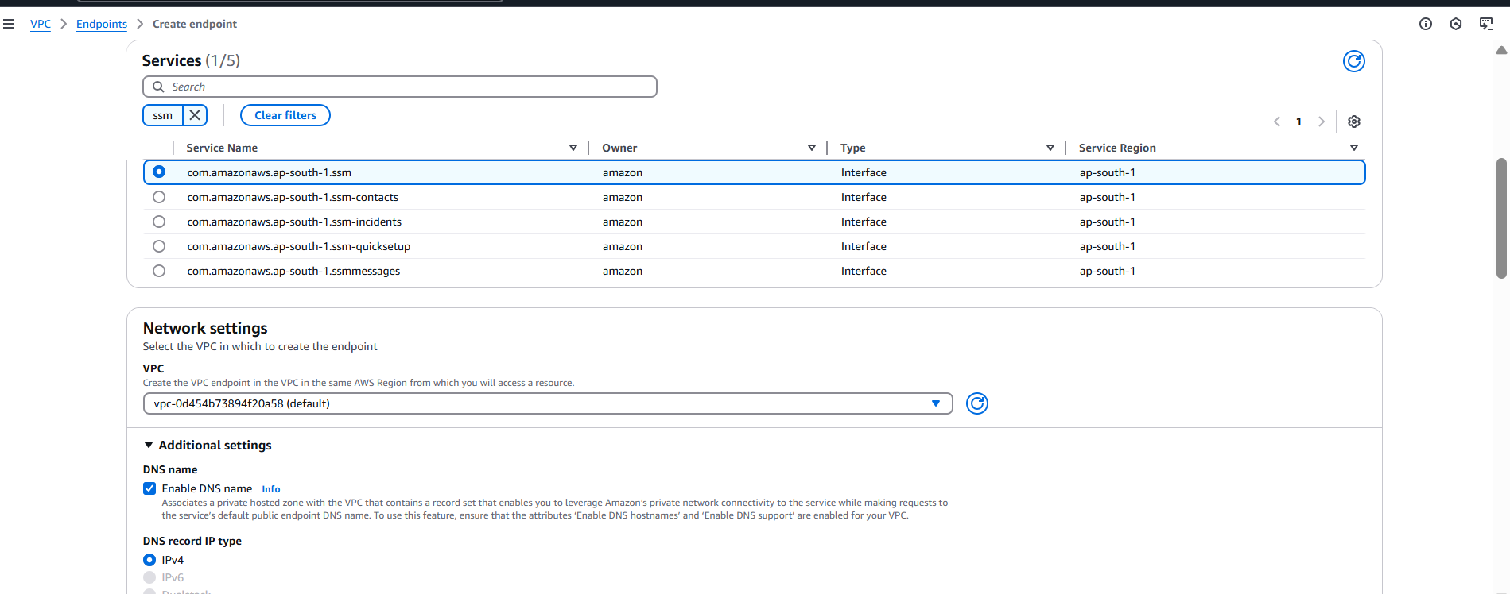

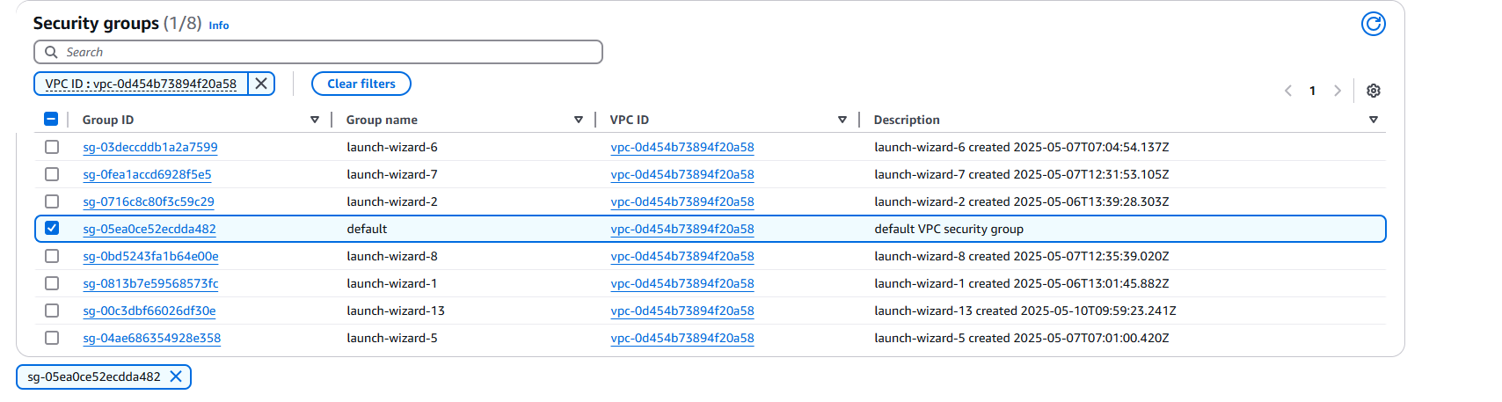
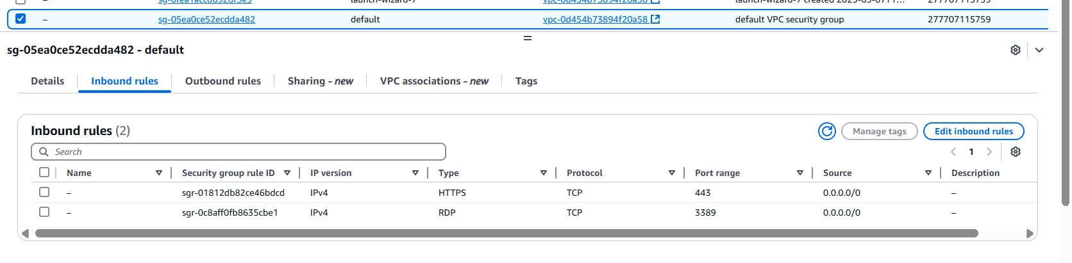

Step 3. Create the endpoint
Test:
Make sure EC2 instance has:
-IAM role with - AmazonSSMManagedInstanceCore
-No public IP or NAT
-Run:
aws ssm start-session --target <instance-id>
If it connects — your interface endpoint works.

